**WATER BROTHERHOOD**

**WATER AND HUMAN CIVILISATION**

[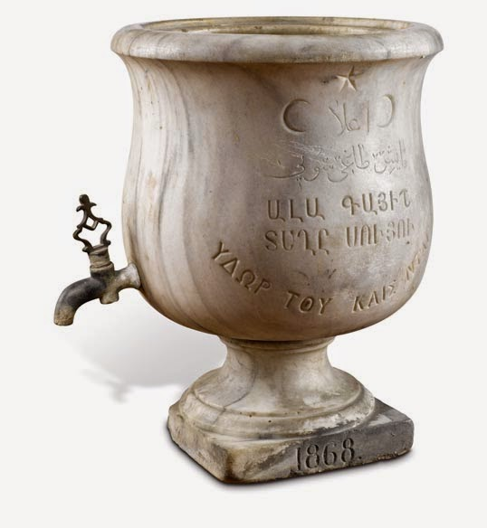](http://1.bp.blogspot.com/-YvRaHNnoG6A/VAit6Zu1IPI/AAAAAAAACUM/BHQAW_-0b7I/s1600/water+1.jpg)The Sumerian texts constitute man's oldest known written documents and in the Gilgamesh Epic the term "Garden of the Sun" was used to signify the concept of paradise.

As mentioned in the Old Testament, the exact location of this heavenly area was the Anatolian Turkish landmass lying between the sources of the Tigris and Euphrates Rivers.

"Then the lord God planted a garden in Eden, in the east, and he placed there the man he had formed. A river rises in Eden to water the garden; beyond there it divides and becomes four branches. The name of the third river is the Tigris; it is the one that flows east of Ashur. The fourth river  is Euphrates. Old Testament. Genesis (2:10-14)

[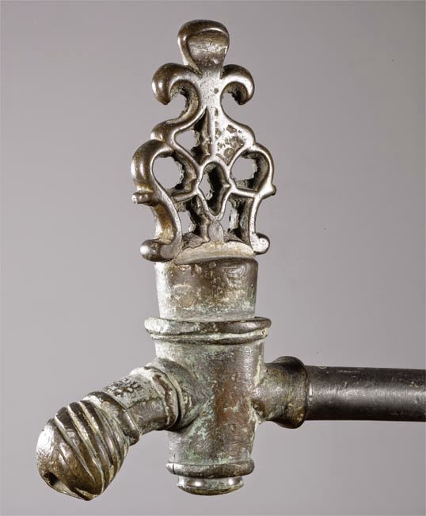](http://2.bp.blogspot.com/-LVNxG_jWn-g/VAit9sZz9EI/AAAAAAAACUU/WnCKLvueJ44/s1600/water+2.jpg)  
"The “Garden of the Lord" mentioned in the Book of Genesis in the Old Testament is called Eden, and is synonymous with "heaven” or "paradise”.

Water has invaluable contributions to human civilisation on earth.  
  
Human can survive without food but not water.

We are all human brothers were born to earth with drop ofwater and farewelled with water again.

[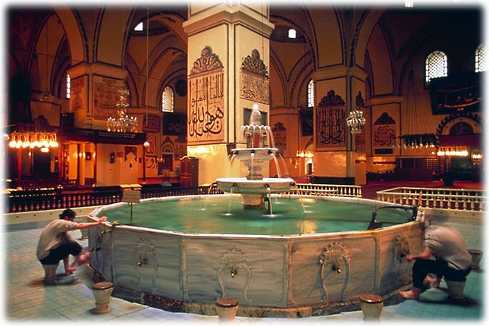](http://4.bp.blogspot.com/-tCDnYJmZaqc/VAiuAidAqEI/AAAAAAAACUc/KXD92uMNc7I/s1600/water+3.jpeg)  
We, Turks, has created a w​ater civilisation from Danube to Euphrates  and Tigris and from Nile to Volga with architectural monuments of bridges, water belts, baths (hammams), shadirvans and fountains.  
  
Turkish Bath is world famous.

Turkish Construction History hosts the first examples of the water architectural monuments created by the mankind in the world.

**AB-ı Hayat Anatolian Water Civilizations Museum, Istanbul, Turkey**

Ab-ı Hayat Anadolu Water Civilizations collection, museum and events are the sustainable social responsibility project of Adell Faucet & Valve Manufacturing Co. Inc. We are pleased to undertake and carry out this project in connection with our product groups and to contribute to the cultural and artistic life of our country and the world by producing social benefits.

As a hobby of the owners of the company, the collection of artifacts, which started 35 years ago, turned into a corporate social responsibility project and came into the present day as a thematic museum with it’s activities.

Collection; It tells the story of the reverence and value of the living beings which are created from water in the Roman, Byzantine, Seljuk and Ottoman Empires, which were born and lived in Anatolia and spread to the world,. The stories of each of the works, which bear many traces of hands, eyes and hearts, are more valuable than themselves and each of them carries the details and cultural codes of the period, the life style of the Anatolian people, daily rituals, art, belief systems and civilization elements.

Historical taps, faucets, water containers, pitchers, basins, boilers, healing bowls, clogs, towels, manuscripts in our collection are made of copper, bronze, ceramics, earthenware, leather and wood. Each of the works that are witnesses of time and they are unique works made with traditional Anatolian handcrafts such as shaping copper, weaving, calligraphy, ceramics, marbling and miniature.

We want that this heritage, which is a common accumulation and acquisition of the humanity of the world, this civilization should not be left unattended and disappear. Let our children and people all over the world know the richness, universal message and civilization values ​​of Anatolia.

We want all people, animals and plants to be gathered under the umbrella of the “World Water Brotherhood” without any distinction of religion, language, nation and color, and that water should be instrumental in peace, love and unity of our world, not wars.

We want to contribute to the construction of a sustainable future where the greatest common value of all living things are loved, preserved and protected, moreover using water effectively without wasting it. Water shortage shouldn’t be a cause of diseases and deaths in any part of our world, the people of the world have reached the water and we do not worry about thirst for future generations.

**TEMPORARY EXHIBITIONS – 2019 – “HEALING FROM WATER” EXHIBITION**

We care that our collection will meet with our students, people from 7 to 77 years in Turkey and abroad. For this purpose, we bring together our civilization values ​​with the people of the region, city, country and the world by opening poster exhibitions consisting of temporary exhibitions of products and posters with sometimes product visuals and English-Turkish explanations. Our exhibitions attract students and local people from young to old.

From time to time, the concept and products are changed and shared with people from domestic and abroad, scientists, government administrators and students to understand all aspects of a wide civilization.

In 2019 we opened an exhibition entitled Water Healing from Past to Present Water Culture at Pendik Municipality Mehmet Akif Ersoy Culture and Art Center in Istanbul. The exhibition consists of unique works in our collection fromAdell Ab-ı Hayat Water Civilization. Curated by Erkan Doğanay, the exhibition presented a nostalgic experience.

**Adell Ab-ı Hayat / Collection of Water Civilization**

Water is the life, the elixir of life. Water, having the power of purification and cleaning, is the symbol of purity, simplicity and wisdom in all civilizations. Ab-ı Hayat (Adam’s Ale), the water of immortality, means sweet and fresh water whose drops give an endless life. Fountains, hamams (Turkish public baths), ‘şadırvan’ (a fountain used for ritual ablutions), cisterns, water canals and aqueducts have risen as the artifacts of this civilization throughout history. That’s why we named our collection of water civilization as “Ab-ı Hayat (Adam’s Ale)” as an expression of tribute and respect to water.

Adell Armatur collects historical artifacts related to our water civilization as a sustainable social responsibility project in order to improve public awareness about water, introduce the water civilization and hamam culture from past to present, bring the values sinking into oblivion to light. It also organizes trainings and seminars, and holds exhibitions on water saving and water management. Our Ab-ı Hayat (Adam’s Ale) Collection of Water Civilization aims to present the phases of our water civilization with its deep rooted history.

Some parts of the Adell Armatur collection were exhibited at the World Water Forum, in 2009. The exhibition “Past to Present Water and Water Culture in Istanbul” was held within the İstanbul 2010, European Capital of Culture events. The exhibition “From the Source to the Demijohn” was held at the 3rd İstanbul International Water Forum in 2011; “Bathing in the Ottoman tradition – Hamam” was held at Tuyap Unicera Fair in 2011; “Living with water” was held at the Tuyap Unicera Fair in 2012; and lastly “The Friends of Water” was held at the Tuyap Construction Fear in 2012. Adell Mixer took part in the organization committee of the International Conference on “Water in ancient civilizations” and presented 3 declarations at the conference.

Adell Armatur collection of water civilization is exhibited at a permanent exhibition hall of the head office in İkitelli Organized Industrial Zone and is open to visits. You can discover details of Ab-i Hayat Water Collection activities our web site.

[http://sumedeniyetimuzesi.com](http://sumedeniyetimuzesi.com/)

[**Chinese Philosophy and Water**](http://leventagaoglu.blogspot.com/2014/09/chinese-philosophy-and-water.html)

[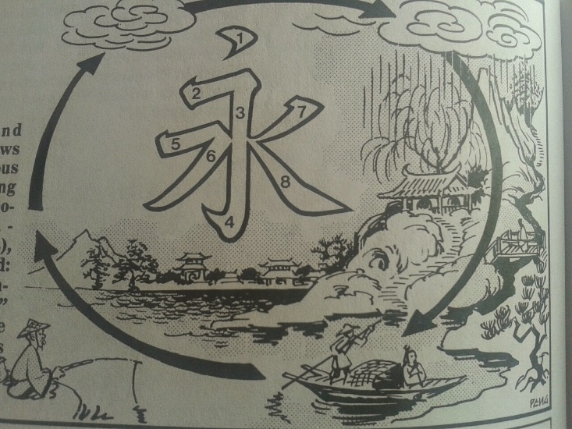](http://2.bp.blogspot.com/-29NWfPsxCVQ/VAixtSRiPOI/AAAAAAAACU0/j_sSAt9m2A8/s1600/20140503_185429_resized+(6).jpg)

YONG: Everlasting; Perpetual; forever

One generation comes and and another goes, but water flows on incessantly in a continuous cycle.

From this unceasing flow of water came the ideograph for "everlasting": a variation of water, with foams and ripples added: water will be remembered as the "everlasting" character that embodies the eight fundamental strokes used in calligraphy.